Future Sales Prediction
Data Analytics Project

Kavishankar K S
BTech Computer Science Engineering
PES UNIVERSITY
Bengaluru, Karnataka
kavikidadumbe@gmail.com
PES1201802001
Rohan.M
BTech Computer Science Engineering
PES UNIVERSITY
Bengaluru, Karnataka
rohan.m.rohan7@gmail.com
PES1201801798

Abstract— Aim of this Project is predicting total sales for every product and store in the next month on the basis of previous months sales data, which helps people to get profit in their business.

Table of contents
- Data Set and Description
- Items.csv
- shops.csv
- item_categories.csv
- sales_train.csv
- Import Packages
- Pre-Processing Data Set
- Training Model
- Prediction and Conclusion

Data Set And Descriptions

Items.csv
Data set has information of item names, item id and also item category id.
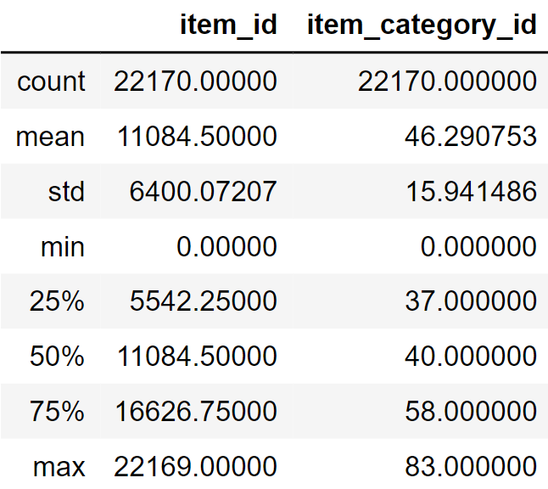

Shop.csv
Data set has information on all shop names and respective shop id
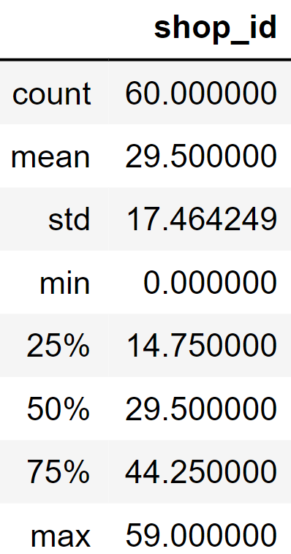

Item_categories.csv
Data set has information on item categories and its respective item category id
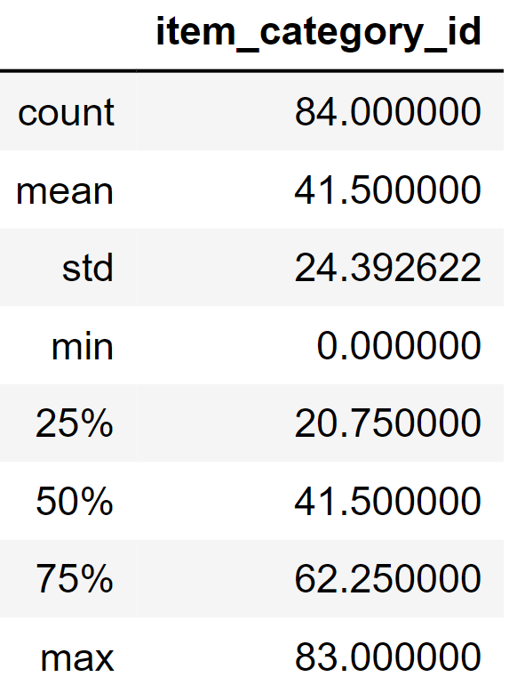

Sails_train.csv
Data set has information on date, shop id, item id, item price and item count sale in a day
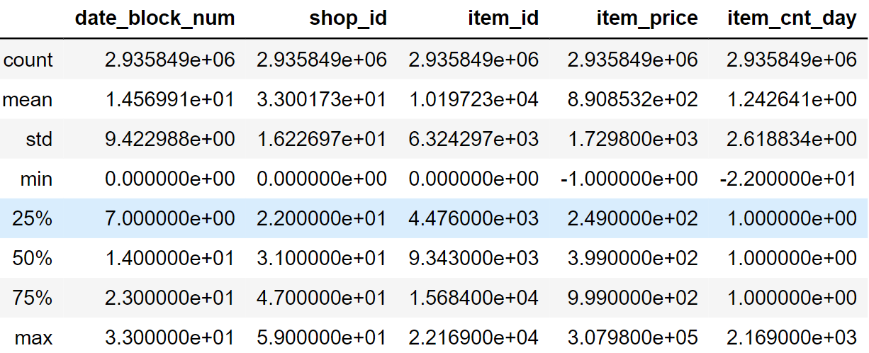

Imported Packages

numpy
numpy is a high-level mathematical function to operate on these arrays.

Panda
Used for data manipulation and analysis. In particular, it offers data structures and operations for manipulating numerical tables and time series

Seaborn
It is a Python data visualization library based on matplotlib. It provides a high-level interface for drawing attractive and informative statistical graphics.

Pre-Processing

NULL values removing
No NULL values

Duplication
No duplicated values

Outliers values
There are some outliers which are easily detected by box plot like some having count greater than 2000 and some are negative values are detected. During EDA
Below image represents boxplot for item count per day
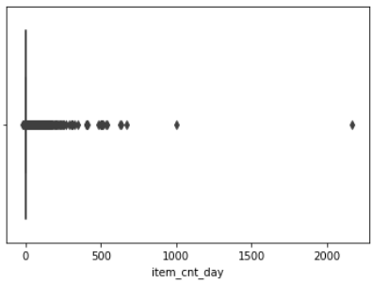
We use Mahala Nobis distance for initial 1000 elements to detect the outliers. After plotting boxplot, we got to know that the items having sales count less than 30 are more accurate i.e., there are on the same concentration on boxplot but others are deviated most.
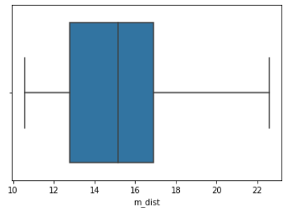

Framing trainable data
We removed some of the columns which having less or no variation in the sales train dataset. Then we divided entire dataset based on monthly sale of item by counting the sales of each individual month in the dataset.
The given dataset has date format we then divided it based on the day month and year format.

IV VISULIZATIONS
Some of the plots for to look into insights of data
Plot to analyze how sales is distributed between consecutive years here we made plot item sold in day and the year unstack parameter.
In the following plot we are noticed that festivals in Russia affected the sales because during some festivals their spike in sale every year most being at December month.
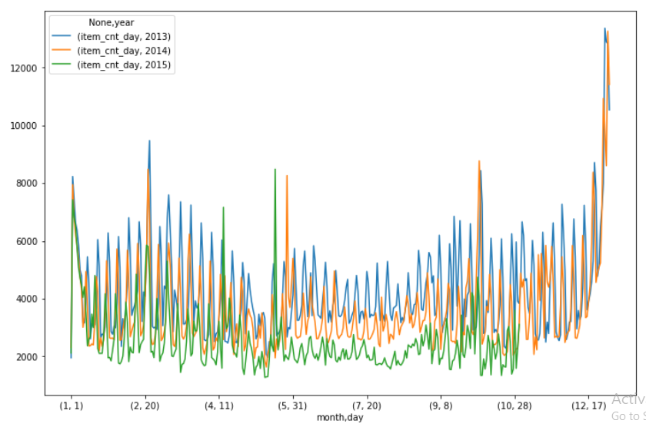

Plot of items sold in a store and store id
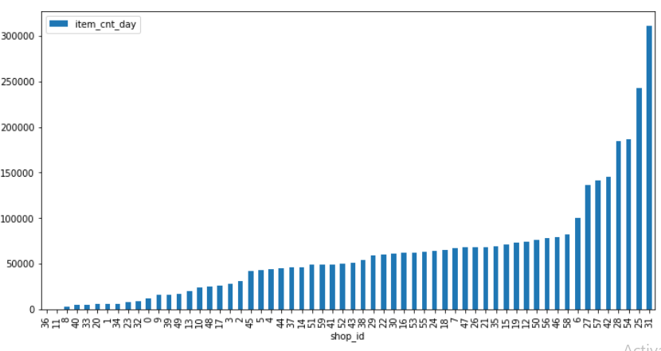
Shops sales every year
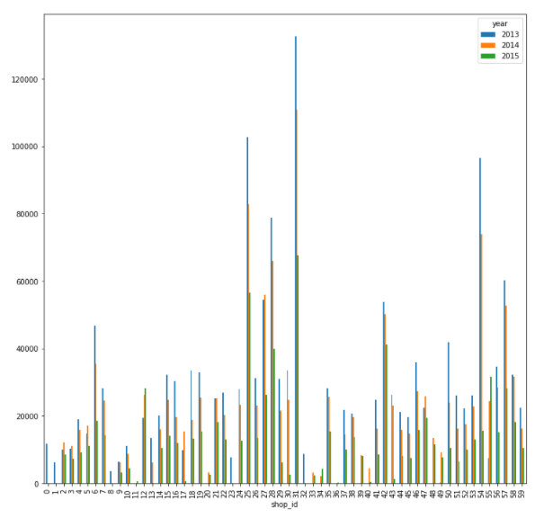

v.Training Modules
Data Set has a total of 34 months count of items sold.
First, we train 67% of our data set and compare it with remaining 33% to check the accuracy of prediction.
We use Sklearn Python library, decision tree classifier (DTC) and decision tree regression (DTR) to train out data set and predict the sales of 34th month. 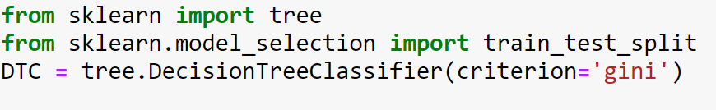
We split up the data based on month and taken 4 columns for final prediction from dataset to train the model we then split the dataset in the ratio of 90% train data set and 10% of test dataset
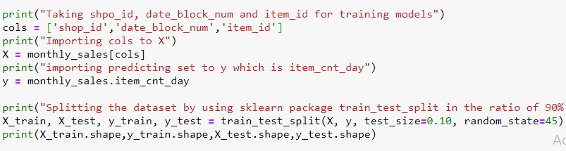
We train the model using two types of model one is Sklearn Decision tree classifier and one more using regressor model
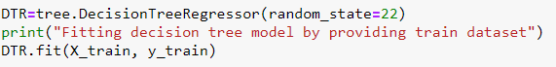

vi Predicting phase
Predicting the final results of the models after training the model is done by predict function so here, we predict the data based on the training results given to the model we take the predicted results in a variable and compare them with test data to calculate the prediction accuracy of the model by comparing predicted results with test data set.
Predicting the results by using decision tree classifier model and finding accuracy of the predicted result.

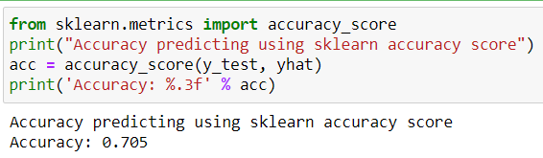

Predicting the results by using decision tree regressor model
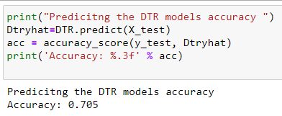
Finally, we predict the prediction for 34th month using whole dataset as train data and we store the result dataset in Future_sales_prediction.csv file.
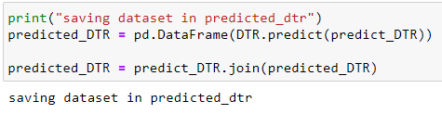

VIII CONCLUSION

By visualizations we end up with detecting possible outliers in out data and we train the model with sklearn trees models and accuracy of prediction is slightly low because the is sale is decreassing year by year in greatly manner data is not distributed in sequence. We wanted to some more model to predict the results with most accuracy which helps exact prediction of the data. In the field of marketting they evry seller want to know the trend of selling his products to customer to over supplies demand of his product and he can take decision to improve his sales.

References
1.Datasets are taken from Kaggle website- Predict Future Sales | Kaggle

2.Decision trees - 1.10. Decision Trees — scikit-learn 0.23.2 documentation (scikit-learn.org)

